Pass data through component tree

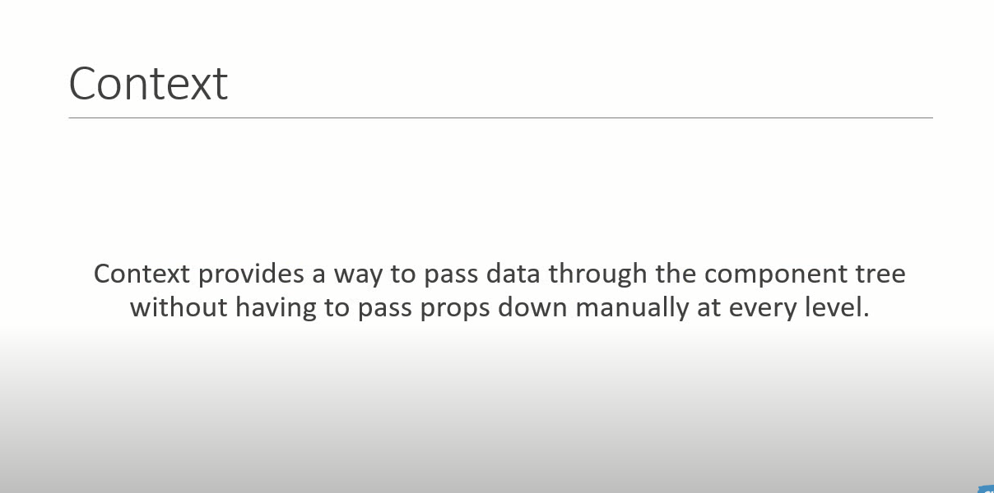

Steps To Create Context :

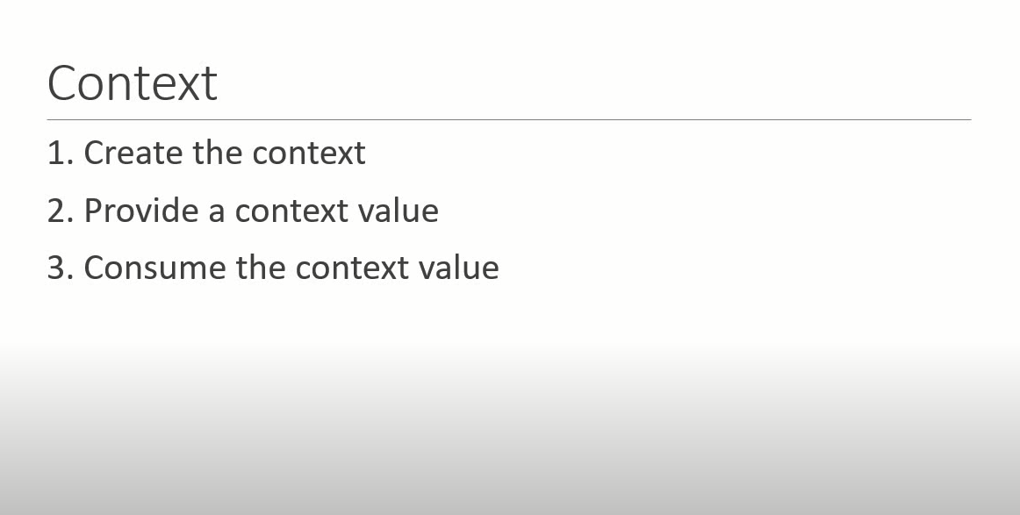

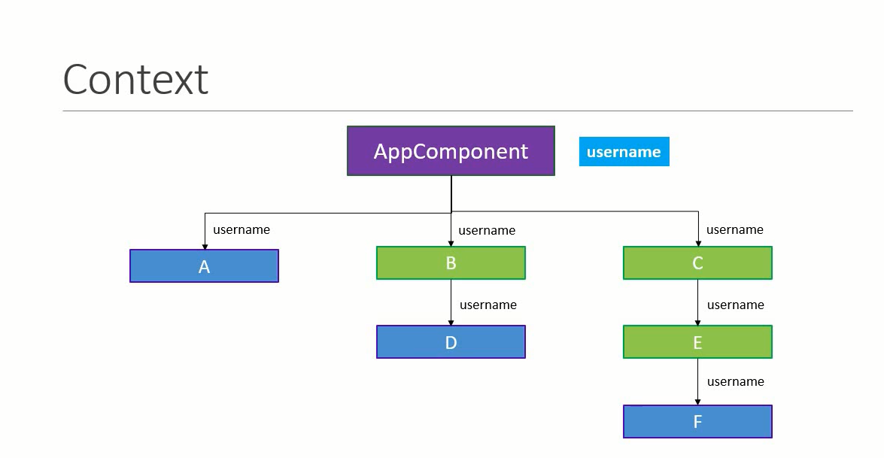

Create Example For this diagram :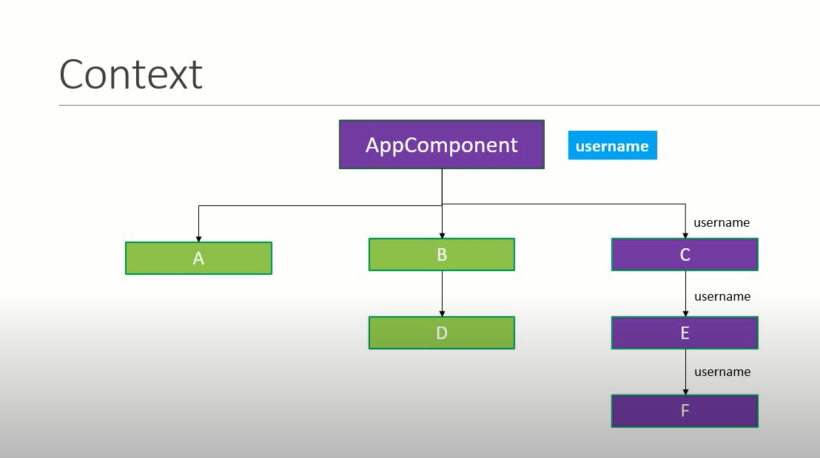

Create One UserContext.js :

In UserContext component we are creating Context using React.CreateContext()

import React from "react";

//Steps 1  : here we are creating context

const UserContext = React.createContext()

const UserProvider= UserContext.Provider

const UserConsumer = UserContext.Consumer

export {UserProvider, UserConsumer}

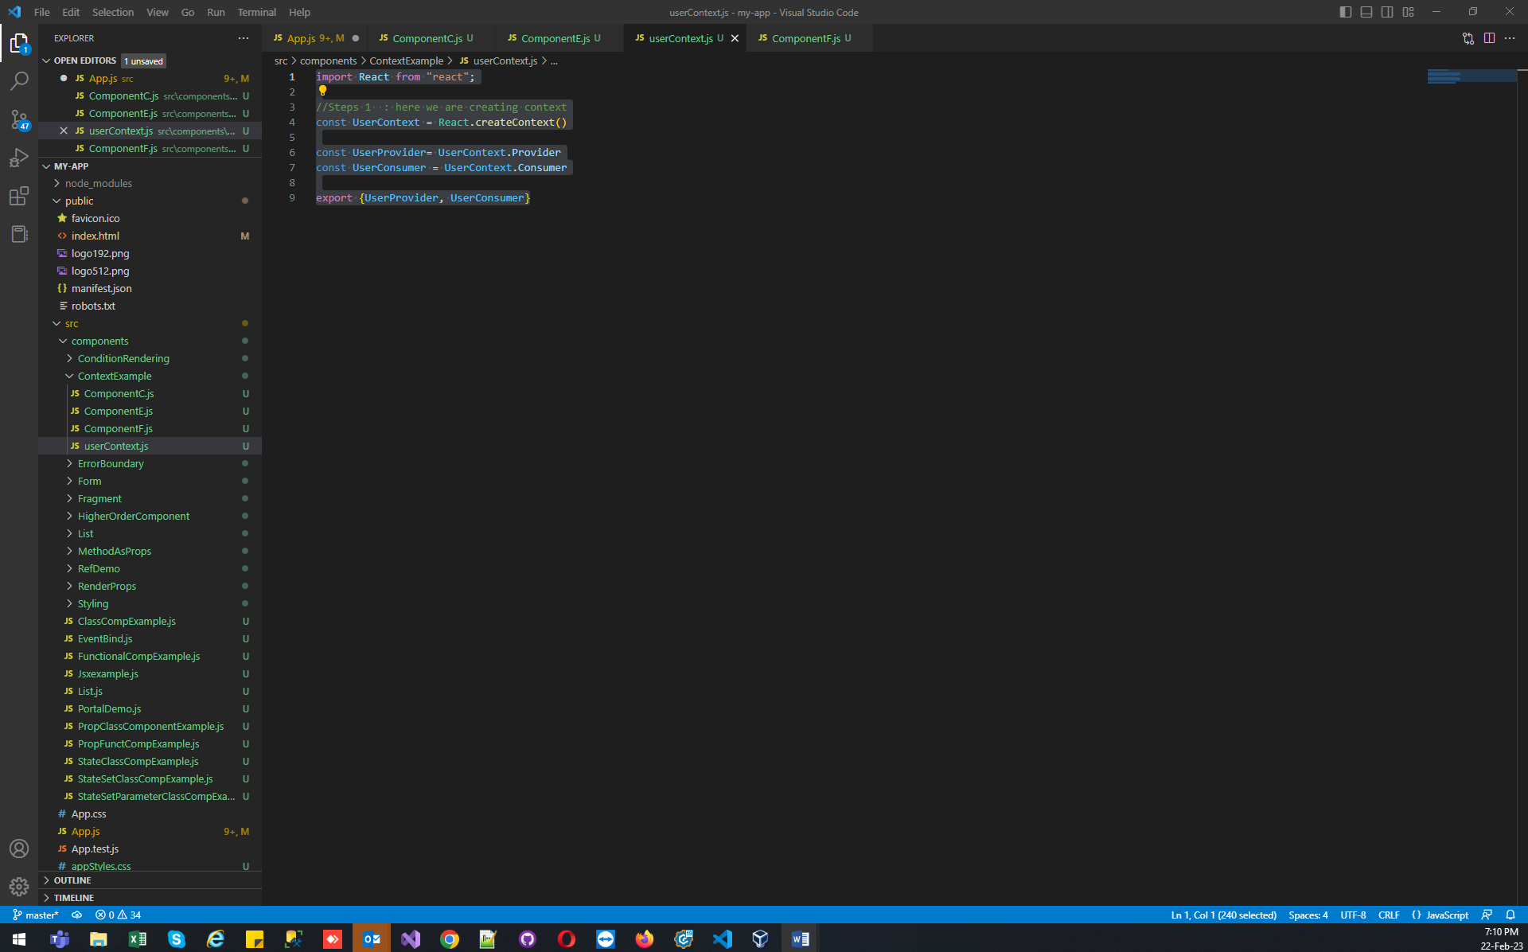

In App.js : call Parent First Component Like ComponentC inside our Context Component like UserProvider

{/\* Step 2  \*/}

<UserProvider value= "Subhishek">

  <ComponentC />

</UserProvider>

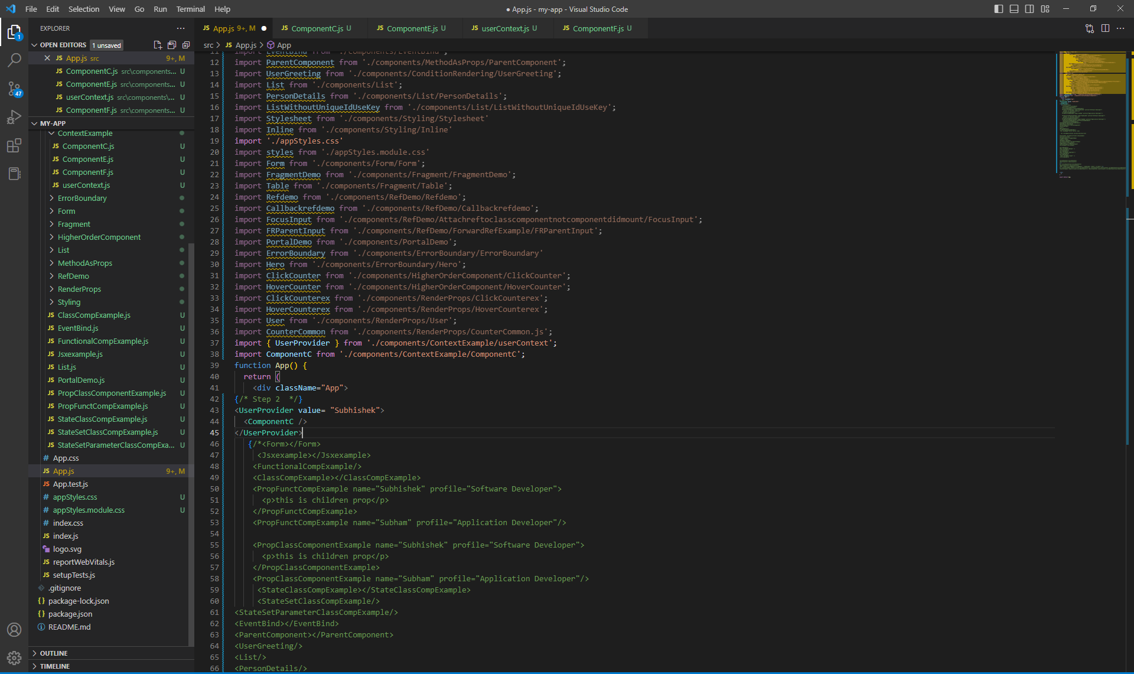

In ComponentC We are Calling ComponentE :

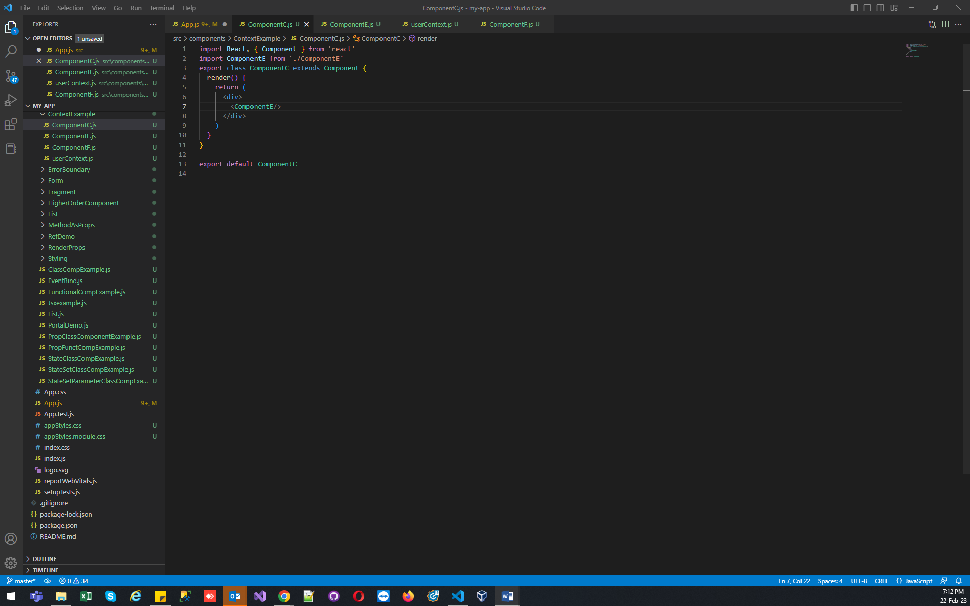

In ComponentE we are Calling ComponentF :

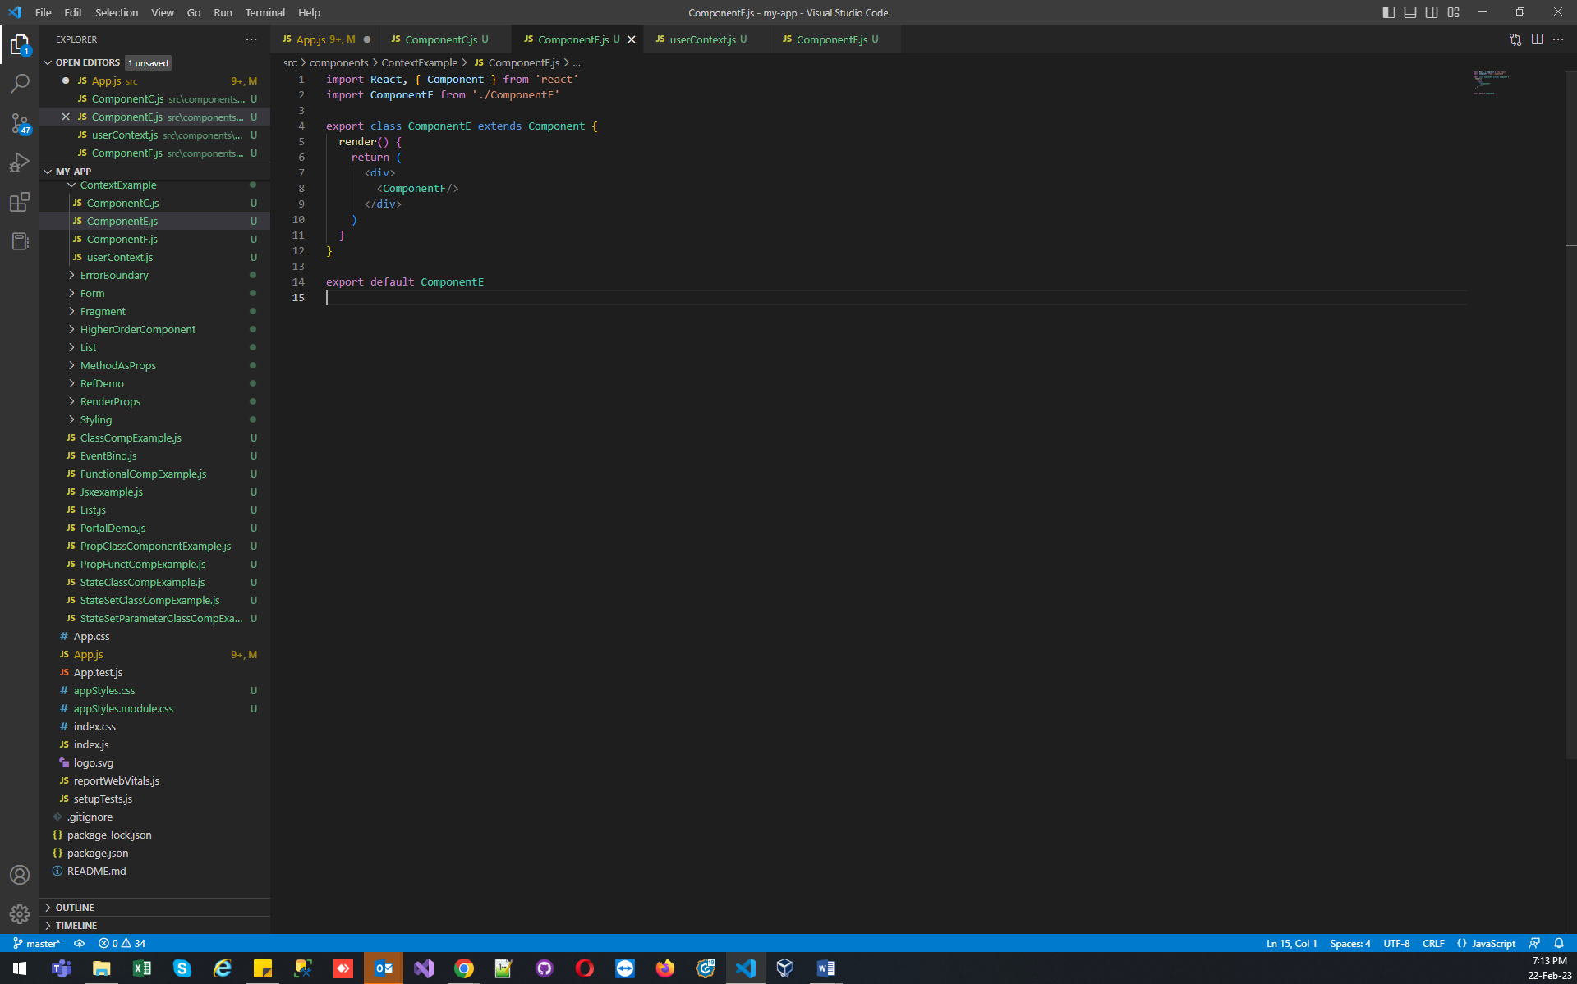

In ComponentF We are going to user our context :

import React, { Component } from 'react'

import { UserConsumer } from './userContext'

export class ComponentF extends Component {

  render() {

    return (

      <UserConsumer>

        {

            (username)=>{

return <div>Hello {username}</div>

            }

        }

      </UserConsumer>

    )

  }

}

export default ComponentF

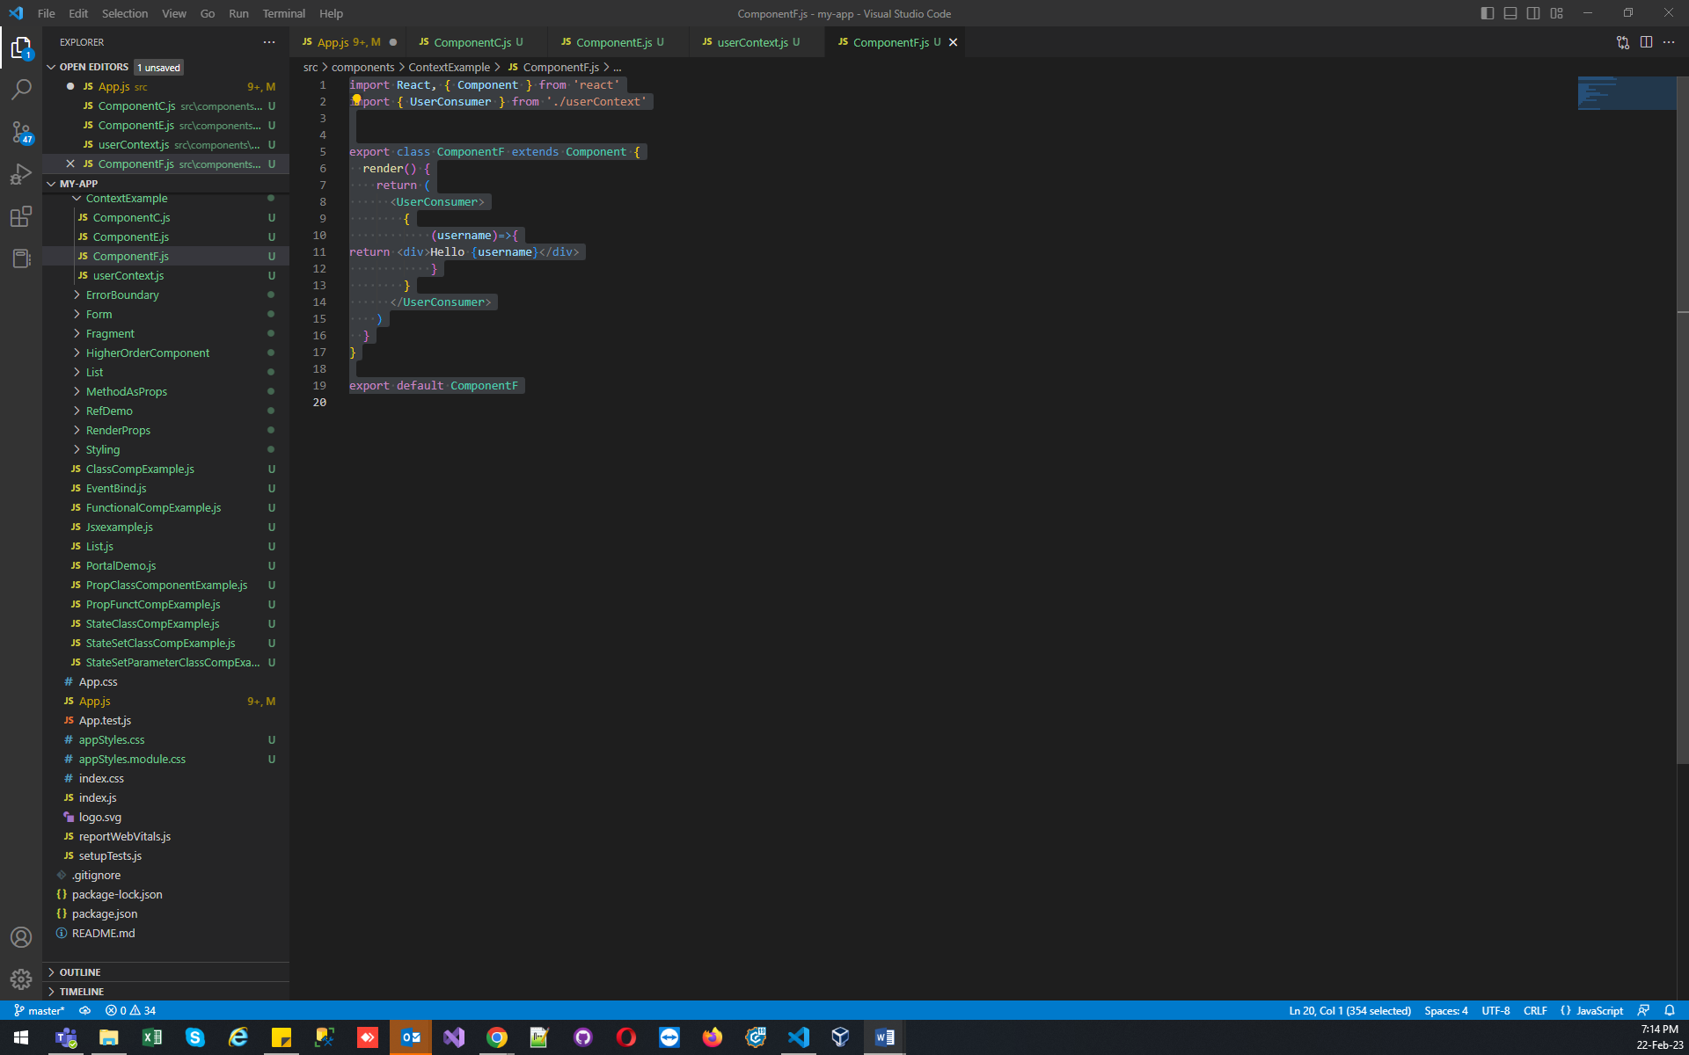

OutPut :

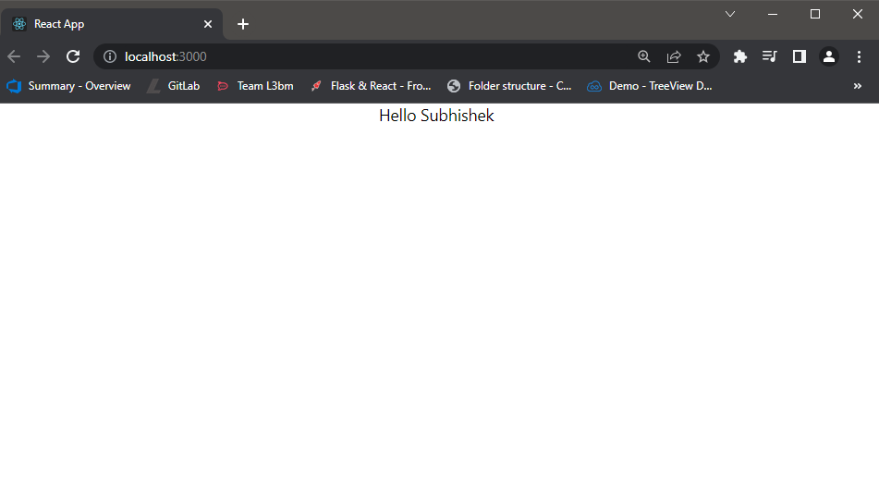

In Context We can also set default value if we are not passing it will show that value :

const UserContext = React.createContext('Subhi Normal User')

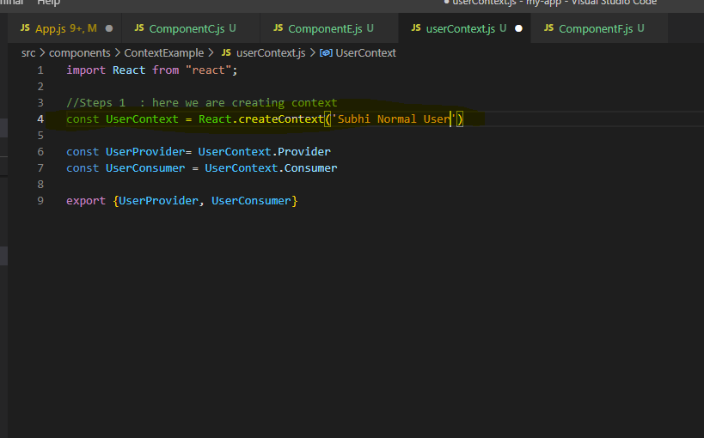

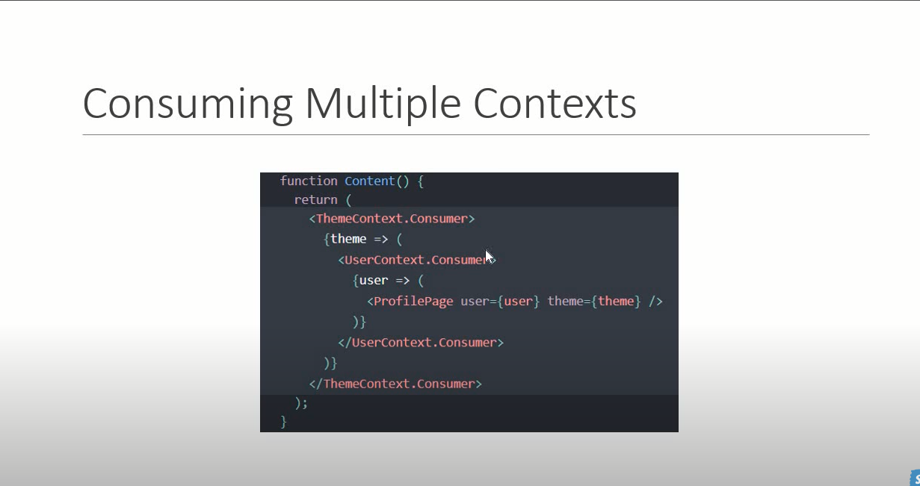

Context Type :

* ContextType Limitation :

1. It is only work with class component
2. You can subscribes only single concept using context Type

Example :

Export Whole Context

import React from "react";

//Steps 1  : here we are creating context

const UserContext = React.createContext('Subhi Normal User')

const UserProvider= UserContext.Provider

const UserConsumer = UserContext.Consumer

export {UserProvider, UserConsumer}

//this added for giving context type example

export default UserContext

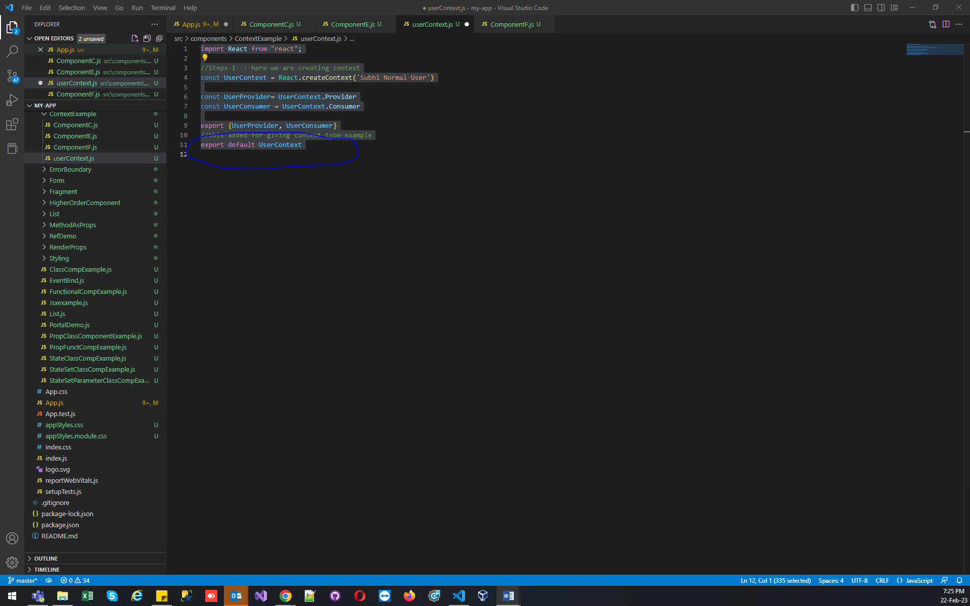

In ComponentE :

import React, { Component } from 'react'

import ComponentF from './ComponentF'

import UserContext from './userContext'

export class ComponentE extends Component {

  render() {

    return (

      <div>

        {/\* And render here context \*/}

        Component E Context {this.context}

        <ComponentF/>

      </div>

    )

  }

}

//Add here for contextType

ComponentE.contextType=UserContext

export default ComponentE

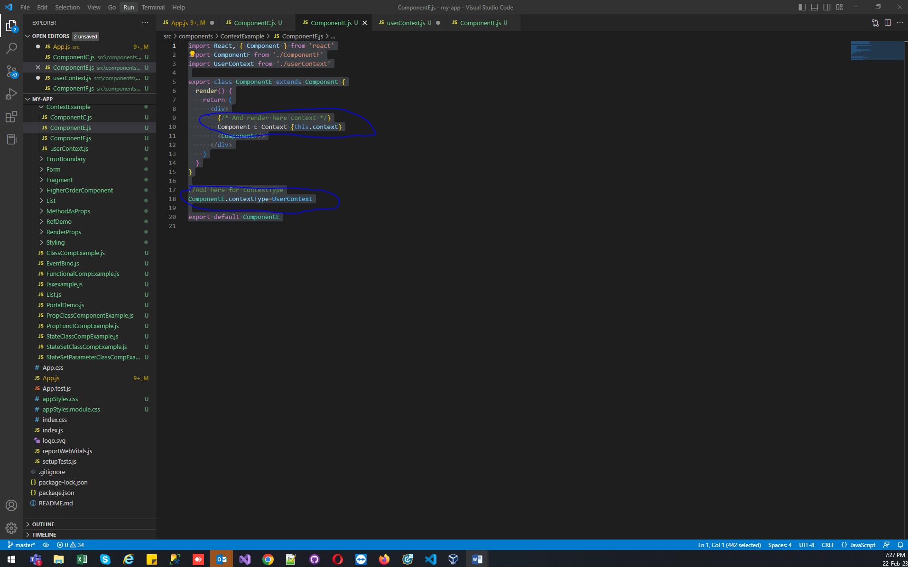

Output >

